STUDENT LOGIN INSTRUCTIONS for ALEKS

- Go to https://www.aleks.com/

- Click Sign up now

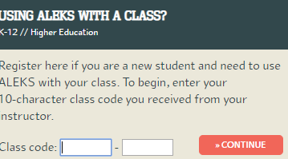
- Enter the class code:

1st period Class Code: GCK3M-PPUKW

4th period Class Code: HW9CM-CEQUF

- Fill out all of the information to make your login name and password

- This will be used as “Web Assign” during this unit.

