1. Define and provided examples for the following types of waves:
   1. Transverse
   2. Longitudinal
   3. Surface
2. What is the only factor that affects the speed of a mechanical wave?
3. Define and list the variables for the following terms:
   1. Frequency
   2. Period
   3. Wave Speed
   4. Amplitude
   5. Wavelength
   6. Sound Intensity
4. Sketch and label the following diagrams:
   1. 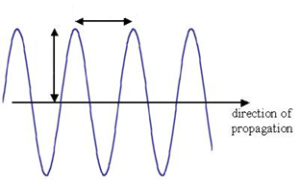Transverse Wave:
   2. Longitudinal Wave:

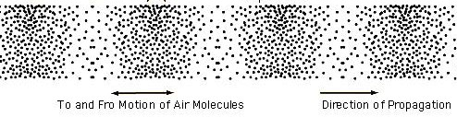

1. Define and sketch a diagram for each of the following wave behaviors:
   1. Constructive Interference
   2. Destructive Interference
   3. Reflection
   4. Fixed vs. Free Reflection
   5. Refraction
   6. Diffraction
2. What is the superposition principle? What does it mean for mechanical waves?
3. Define pitch; what wave property is it most closely related to?
4. Define loudness; what wave property is it most closely related to?
5. If frequency changes, what other wave properties are changed? Are they directly or indirectly related?
6. How does air temperature affect the speed of sound? List an equation to support your reasoning.
7. Define the following terms:
   1. Infrasonic frequencies
   2. Ultrasonic frequencies
   3. Subsonic speeds
   4. Supersonic speeds
8. Define the Doppler Effect. How does the apparent frequency shift for an observer based on the motion of the source?
9. A tuning fork with a frequency of 480 Hz is played in a room with a temperature of 25°C.
   1. What is the period of the sound wave?
   2. What is the velocity of the sound wave produced?
   3. What is the wavelength of the resulting sound wave?